**Synopsis**

**on**

**AIO Tools**

**to be developed to fulfill the requirements for**

**Major Project (CA133)**

**Submitted to**

**Department of Computer Applications**

**Chitkara University, Punjab**



**under the supervision of**

**Dr. Rupinder Singh**

**Dr. Rajwinder Kaur**

**Assistant Professor**

**Department of Computer Applications**

**Submitted by**

**Tushar Jaryal Aadarsh Sharma**

**2210987036 2210987001**

**Amit Verma**

**2210987004**

**Bachelor of Computer Applications**

**(Batch 2022-24)**

**TABLE OF CONTENTS**

**1. Abstract**

**2. Introduction**

2.1 Project Aim and Objectives

2.2 Technology to be Used

2.3 Hardware and Software Requirement

**3. System Analysis**

3.1 Software Requirement Specification

3.2 Existing v/s Proposed System

3.3 Software tools to be used

**4. Data Flow Diagram**

**5. Timeline**

**6. References**

1. **Abstract**

Provides a simple set of tools in form of an online dashboard. It would be able to help small and medium vendors to use and track their daily, monthly and yearly sales and growth easily in form of a graph and charts in just few clicks.

We would be following the MERN stack for the implementation of the project with Amazon AWS and a free domain using freedns.afraid.org. The MERN stack constitutes of the following components:

1. MongoDB
2. Express JS
3. React
4. Node JS

The Mongo DB is used for the online database, whereas Node JS is used for the implementation and java run-time environment for development. React, its components and libraries are used for functionality and user interfaces. Express JS is being used for the web application framework. We will providing latest UI Elements to provide the customer or user with an attractive and easy to use Dashboard and web application for easier access and work.

1. **Introduction**

The web application is an interface for the user to access the store details and facilities of the dashboard according to the role of user. Some common functions like Calendar will be given for easy planning by the admin and store manager. The web application can be used to track Sales, Transactions, Employee details and performance. The incentives can be given and calculated according to the performance. The UI is easy to understand and use with latest features and several components available to be added in future according to demand and preference.

The Mongo DB is used for the online database, whereas Node JS is used for the implementation and java run-time environment for development. React, its components and libraries are used for functionality and user interfaces. Express JS is being used for the web application framework. We will providing latest UI Elements to provide the customer or user with an attractive and easy to use Dashboard and web application for easier access and work.

**2.1 Project Aim and Objectives**

* Website providing dashboard and tools to simplify tracking for small vendors.
* Maintaining the employee details, sales details and product details.

**2.2 Technology to be used**

* MERN Stack
* MongoDB
* Express JS
* React
* Nodejs

**2.3 Hardware and Software Requirement**

**Client Side**

|  |  |
| --- | --- |
| Processor | i3 or higher |
| Operating system | Windows 98 or higher or any debian linux distro. |
| Memory | 2 GB RAM |
| Hard disk space | 2 GB RAM |

**Server Side**

|  |  |
| --- | --- |
| Processor | i3 or higher |
| Operating system | Windows 98 or higher or any debian linux distro. |
| Memory | 2 GB RAM |
| Hard disk space | 2 GB RAM |

**3. System Analysis**

3.1 Software Requirement Specification (Functionality to be discussed here)

|  |  |  |  |  |
| --- | --- | --- | --- | --- |
| **No.** | **Requirement** | **Essential or Desirable** | **Description of the Requirement** | **Remarks** |
| RS1 | The system should have a login | Essential | A login box should appear when the system is invoked. | The logins are assigned by the store manager. Login user is email id of the customer |
| RS2 | The system should have a login registration form | Essential | The login request would be send to Sore manager for approval. On approval an email should be sent automatically to the customer email id | Only approved registrations are valid users of system |
| RS3 | The screens visible to user should be role based | Essential | Once the user authentication is the based on the role of a user in this system the screens should be different | UI should be role based |
| RS4 | Dark and Light mode switching | Desirable | Dark and Light mode using a button | UI element |
| RS5 | All components of dashboard visible to use according to role | Essential | Elements on the side bar visible to user according to roles | Essential |
| RS6 | Calendar to give admin and manager a place to plan. | Desirable | Calendar element for admin and manager to plan the month | UI Element |
| RS7 | Store manager must be able to see the purchase history of customer wise, item wise | Essential | Ad hoc query by store manager | Query run in the background |
| RS8 | Store manager should be able to see purchase history in specified time duration | Essential | Ad hoc query by store manager | Query run in the background |
| RS9 | Store manager should be able to see total sell till date and between 2 days | Essential | Ad hoc query by store manager | Query run in the background |
| RS10 | Store Manager should be able to see the performance of the employees | Essential | Backend DB Query | Query run in the background |
| RS11 | Incentives given to the Employees according to their performance | Essential | Financial Query | Query run in the background |
| RS12 | Products reviews and ratings according to their demand and popularity | Essential | Ad hoc query | Query run in the background |
| RS13 | Store Managers can track Employees as well as Customers. | Essential | Ad hoc Query | Query run in the background |
| RS14 | Transactions and users and employees can be added or removed as required | Essential | Ad hoc Query | Query run in the background |

3.2 Existing Vs Proposed

- Physical Method like Notebooks and Textbooks or multiple softwares for any specific task.

3.3 Software Tools to Be Used

- Any Web Browser

**4. Data Flow Diagram**

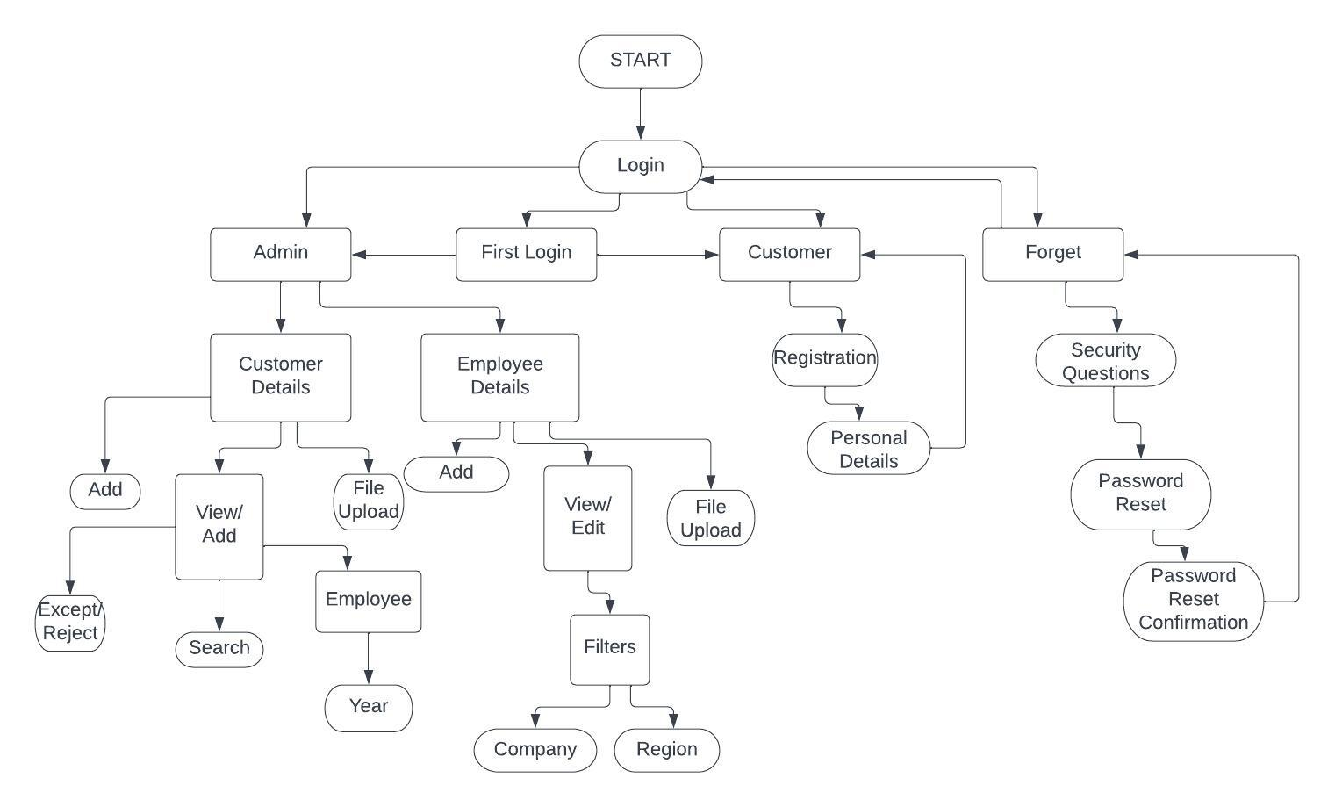

**5. Time line**

|  |  |  |  |
| --- | --- | --- | --- |
|  | **1 March - 16 March**  **2023** | **16 March – 16 April**  **2023** | **16 April – 1 May**  **2023** |
| **Synopsis Submission** |  |  |  |
| **Implementation** |  |  |  |
| **Report Writing** |  |  |  |
| **Final submission** |  |  |  |

**6. References**

SQL, HTML, Express, React, Node - <http://www.w3schools.com>

Free DNS – <https://freedns.afraid.org>